Reflection Report

Unit code: COS40006 EAT40006

Unit Name: Engineering Project B

Submission date: Thursday 29th May 2025

MARCO GIACOPPO (104071453)

## Acknowledgment of Country

I would like to acknowledge the Traditional Owners of the land on which I completed this work—the Wurundjeri People of the Kulin Nation—and pay my respects to their Elders past, present and emerging. I recognize their continuing connection to land, waters, and culture.

I identify:

the [Traditional Owners](https://aiatsis.gov.au/explore/map-indigenous-australia) of the land they lived on while completing this work (if living in Australia)

## Executive summary

This report provides a detailed reflection on my individual journey throughout Engineering Project A and B, focusing on my work in developing a genealogy web application. Over the course of the semester, I enhanced both technical and soft skills through iterative coding, debugging, collaboration, and stakeholder engagement. I contributed significantly to frontend and backend development, implemented complex relationship logic for genealogy visualization, and refined user interface elements. This reflection addresses my personal achievements, the challenges I encountered, the skills I developed, and key takeaways for future project work. Proof of contribution is illustrated through worklog entries, Jira boards, and GitHub branches with merged pull requests.

## Reflection on Individual achievements

At the start of the project, I had basic frontend development knowledge and limited experience in managing complex data relationships. By the end, I significantly advanced my skills in React, modular code structuring, and full-stack integration.

Key accomplishments include:

* Implementing a dynamic side panel with editable fields (name, gender, date, confidence, tags, place of death).
* Developing logic to handle bi-directional family relationships such as spouses, parents, and siblings, including real-time visual updates.
* Leading the modularization of the tree layout code, reducing a 500+ line file into manageable, reusable parts.
* Collaborating with teammates on performance improvements and visual fixes using React Flow.
* Creating and merging branches such as `gender-dropdown`, `name-edit-feature`, `death-panel-fix`, `siblings-sidepanel-fixed`, and others (which has been deleted so I don’t have too many active branches).

These contributions were validated by feedback from our supervisor, Harsharan, and were presented during weekly meetings, including the walkthrough-style demonstration in Sprint 3.

## Reflection on individual challenges

One of the toughest challenges I faced was debugging and enhancing the family tree layout logic. React Flow’s edge rendering system was not intuitive, and ensuring correct placement for nodes representing spouses, children, and siblings was especially difficult.

Some issues I overcame included:

* Overlapping cards and misaligned connections.
* Bugs caused by incorrect handle ID mappings.
* Layout distortion when siblings or parents were dynamically added.

To address these, I:

* Introduced stricter naming conventions for node handles.
* Modularized layout functions.
* Used debug visuals and added edge validation logic.

Additionally, I had to frequently update APIs and database logic to reflect changing requirements such as note fields and image uploads.

## Reflection on individual contribution

My contributions spanned across:

* Frontend development: Added editable form fields, fixed UI layout bugs, and refined card positioning in the genealogy tree.
* Backend integration: Handled data syncing between user input and the database for new fields like gender, deathTown, and editable names.
* Debugging: Led efforts in resolving issues related to tag and confidence syncing, image uploads, and GEDCOM file imports.
* Project management: Participated in all standups, code reviews, and contributed Jira updates.

I also maintained strong communication with team members via Jira task updates and Discord. While I made impactful contributions, one improvement area would be planning for potential layout scalability issues earlier in the development cycle.

## Reflection on individual skill development

Throughout the project, I significantly developed:

* Technical skills: Improved proficiency in JavaScript (React), API integration, database interaction (SQL), and UI debugging.
* Problem-solving: Tackled complex nested relationship logic and implemented scalable solutions.
* Collaboration: Enhanced communication and task delegation using Agile methods.
* Version control: Gained confidence in resolving Git conflicts and managing multi-branch development.

These skills were built through hands-on coding sessions (up to 30 hours/week during peak development), supervisor feedback, and real-time team problem solving.

## Take away

If I were to redo this project from scratch, I would:

* Start with a well-defined schema for relationships and data interactions.
* Allocate more time early on to research visualization libraries to avoid mid-project reworks.
* Emphasize writing unit tests to catch edge-case bugs in the relationship logic.

This project was a milestone in my journey as a developer. It not only challenged my technical abilities but also helped me grow as a communicator, planner, and problem solver. I’m proud of the work completed and excited to apply these lessons to future projects.

## Supporting Evidence

My contributions on the GitHub contributions page may look like it’s not much, but I had some problems with my GitHub a few weeks back, so not all my changes will be stored as my contribution. The arrow highlighting the commits that were pushed by Corey was my contribution to the project.

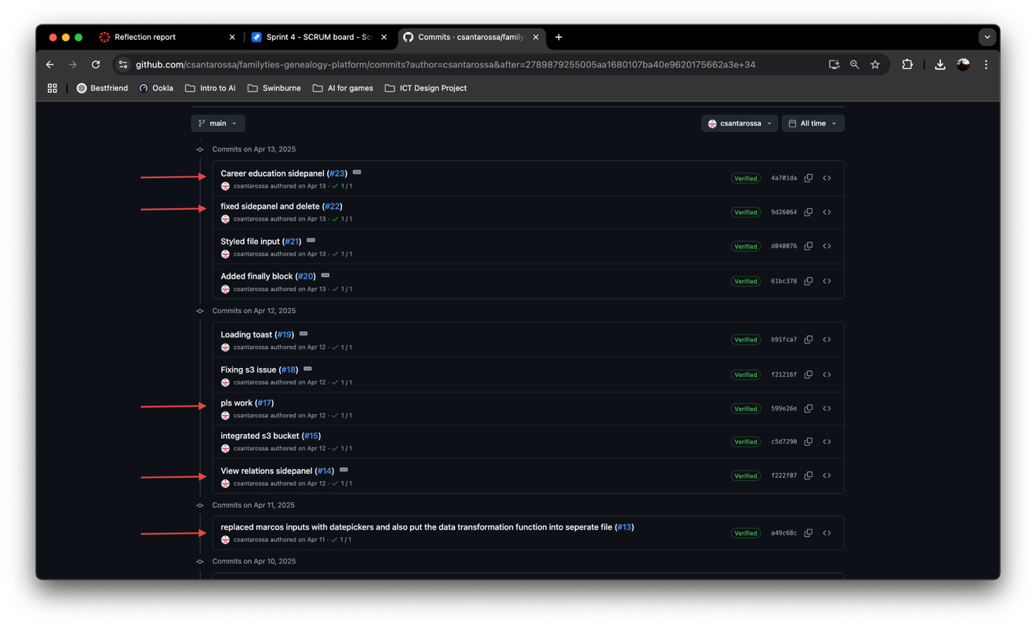

Figure 1: Commits that were pushed by Corey but it was our work together.

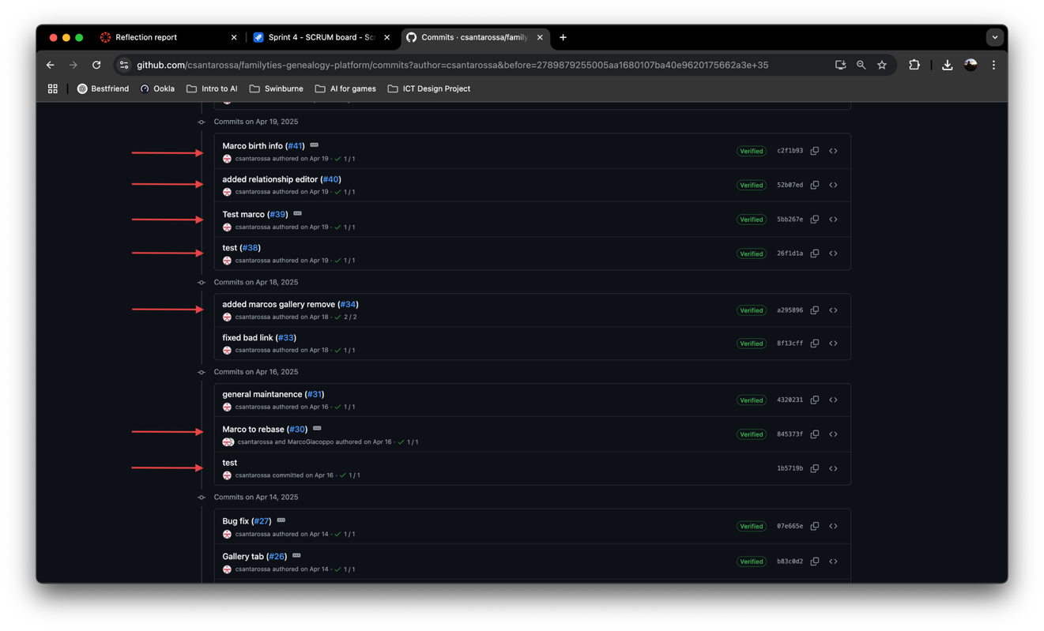

Figure 2: Some more evidence of commits.

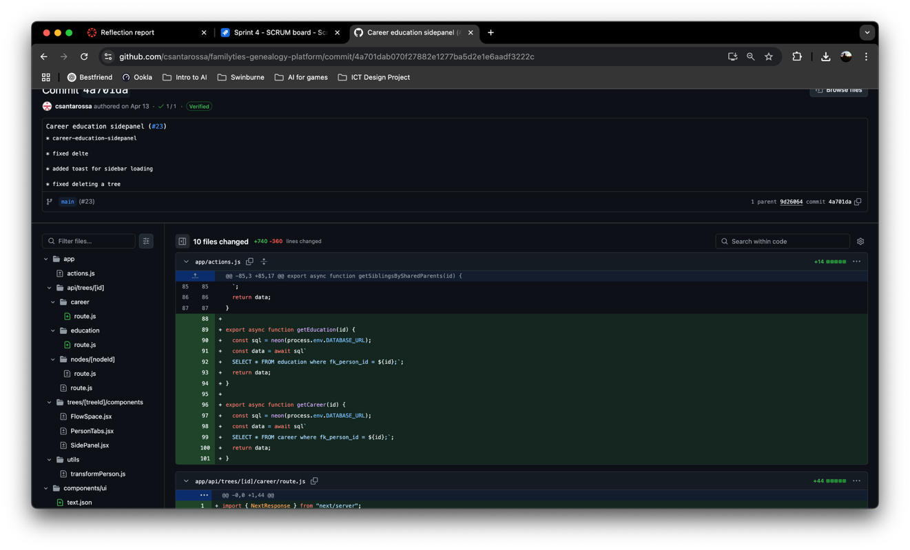

Figure 3: How 1 commit was hundreds of lines of codes.

As we can see on *Figure 3*, one of the commits is hundreds of lines of codes. These was because my task wasn’t a simple ‘Create a Contact Us page’. My tasks were to create the side panel function and make sure they’re all connected to the backend, while still getting all the POST, PUT, DELETE, and all the other API call’s syncing with each other. I was also assigned to find a better way to position the card layout, so it looks like an actual family tree layout.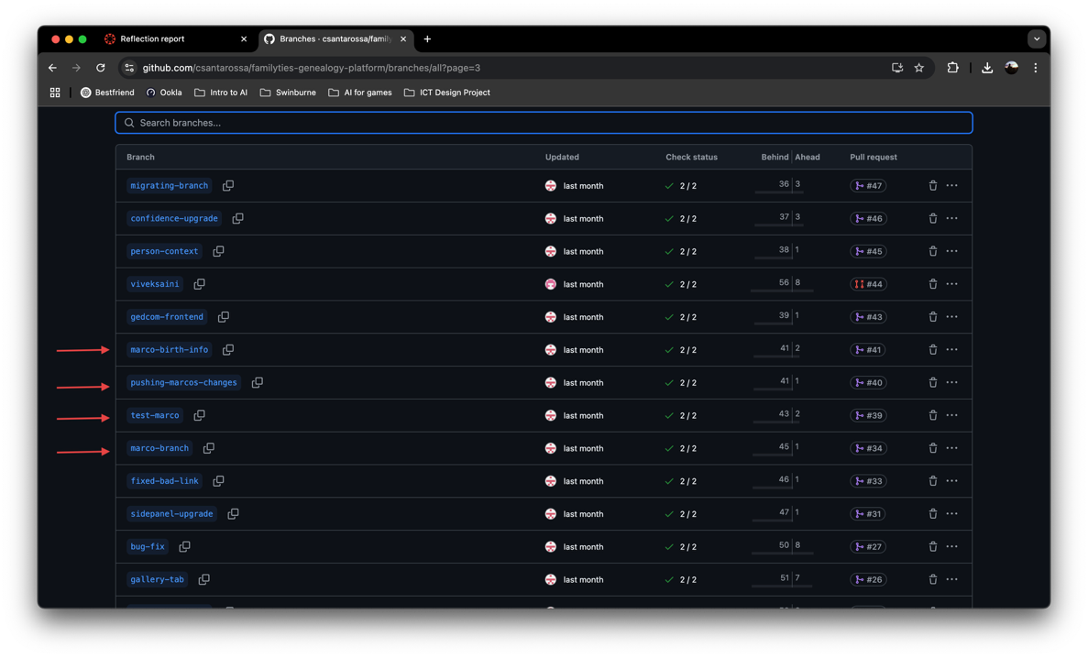

Figure 4: Branches that were mine.

On *Figure 4*, the branches belonged to Corey when it was actually mine because again, I had a problem with my GitHub and we didn’t fix it until Week 8 / 9.

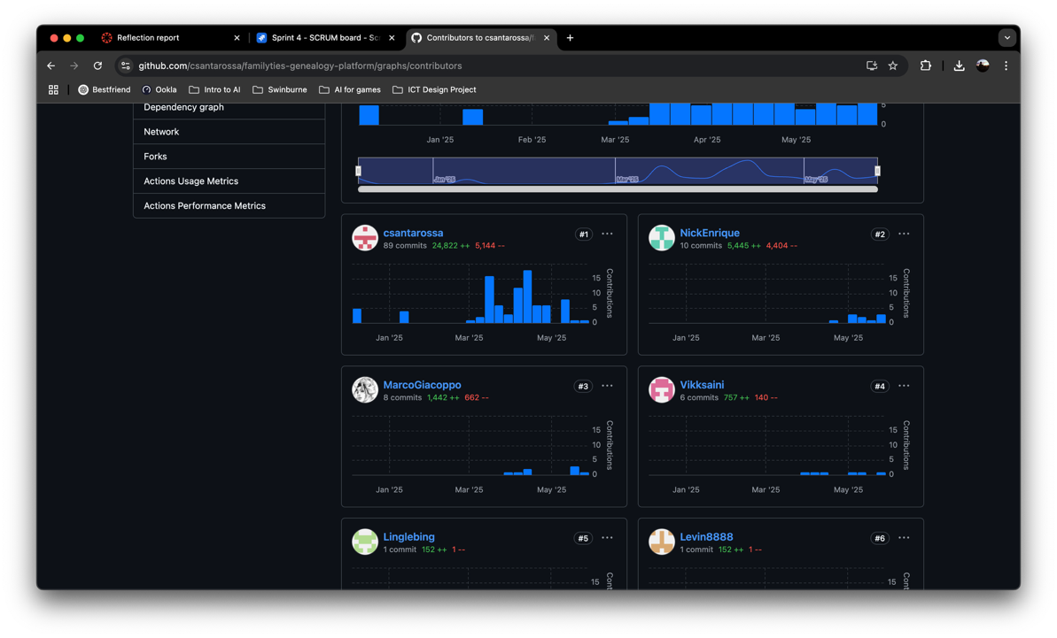

Figure 5: Contributors proof on GitHub.

On *Figure 5*, it’ll say I did only 8 commits with 1.4k of addition and 600 of deletions. When I did at least 15 commits with more than 8 thousand lines of codes.

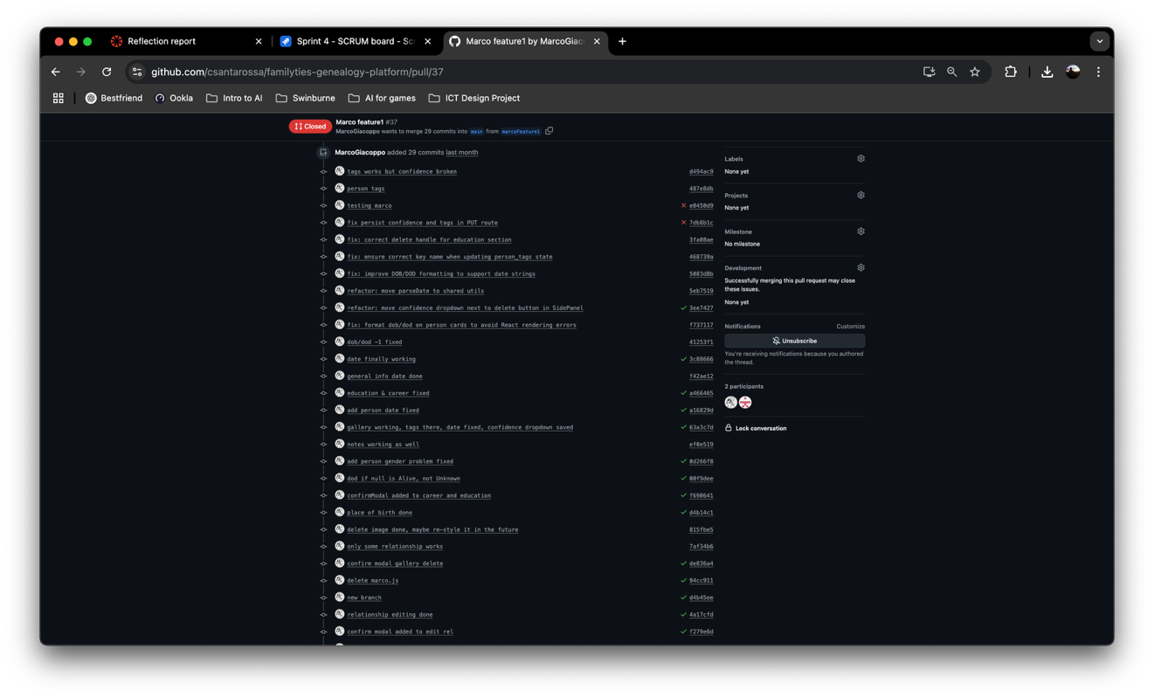

Figure 6: GitHub Pull request that was closed instead of merged because there were to many conflicts

As you can see on *Figure 6,* the PR’s I had been closed due to too many conflicts where I couldn’t pull the latest changes from the main branch resulting in conflicts in numerous files. This is where Corey helped me to take my code and modified it so it wouldn’t cause any conflicts, resulting in my ‘low contribution’ on GitHub’s page. If you see *Figure 6* closely, you can see that all 29 commits were from me. You can refer to Corey’s peer review submission for additional proof.